[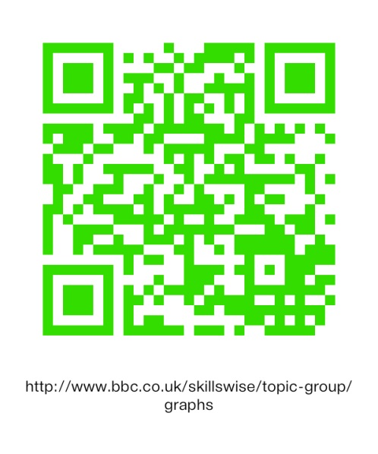](http://www.bbc.co.uk/skillswise/topic-group/graphs) BBC Skillswise

**Handling Data**

[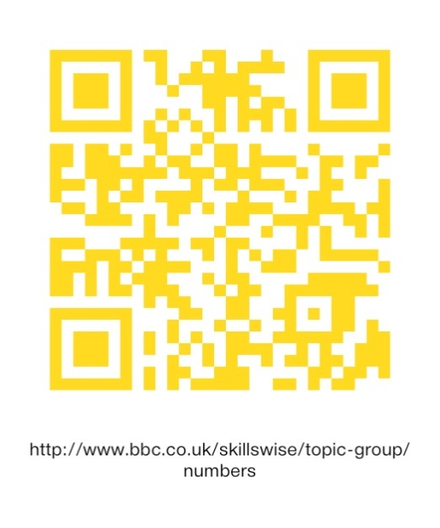](http://www.bbc.co.uk/skillswise/topic-group/numbers)[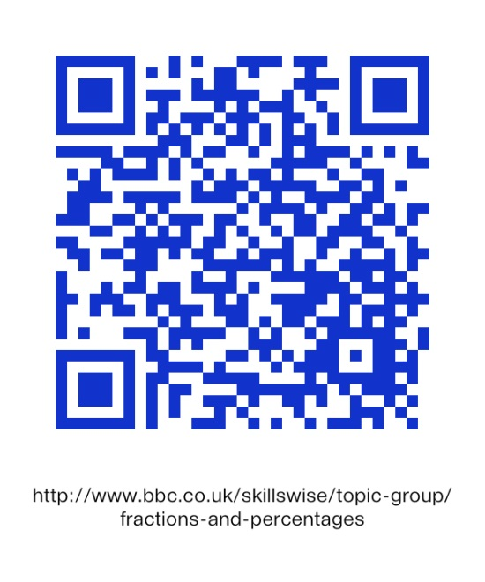](http://www.bbc.co.uk/skillswise/topic-group/fractions-and-percentages)

**Numbers**

**Percentages and Fractions**

**The QR code above links to supporting resources for:**

* **Number lines and symbols**
* **Place value and decimals**
* **Negative numbers**
* **Rounding and estimating**
* **Formulae**

**The QR code above links to supporting resources for:**

* **Fractions**
* **Percentages**
* **Ratio and proportion**
* **Probability**

**The QR code above links to supporting resources for:**

* **Collecting data**
* **Lists and tables**
* **Graphs and charts**
* **Averages and range**